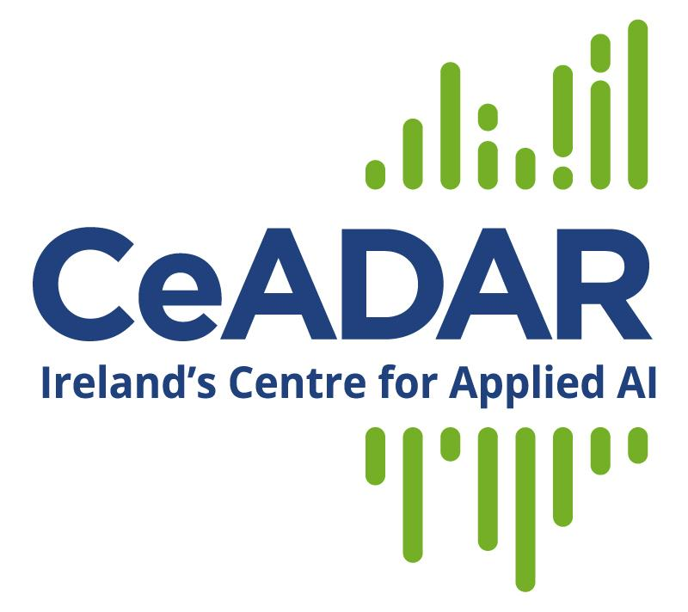
Job Description

Post Title | Software Engineer II (Project Giyst)
Institution | Centre for Applied Data Analytics & AI (CeADAR)  School of Computer Science, University College Dublin (UCD)
Post Duration | Initially until Nov 2022 and Opportunity to join Start-up afterwards
Reports to | Head of Innovation and Development
Apply – Send CV to | To: aditya.grover@ucd.ie  Subject: “Software Engineer II (Project Giyst)”

Position Summary

Applications are invited for the position of Software Engineer II in Ireland’s Centre for Applied Data Analytics & Artificial Intelligence (CeADAR).

CeADAR is seeking an experienced individual who has a demonstrated successful track record in software engineering in industry (>5 years). This is a unique opportunity to join a start-up project being incubated in CeADAR for the last 18 months and to potentially become part of a promising start-up in the area of AI (Natural Language Processing).

CeADAR is based in University College Dublin and conducts applied research in data analytics and develops solutions in cooperation with our industry partners. The applied research at CeADAR covers broad aspects of AI and data analytics including real-time analytics, machine learning, prediction, data visualisation, data management, and data-driven interfaces. This is a unique opportunity to work with a strong team on advanced data analytics projects in collaboration with industry partners and other applied researchers at the cutting edge of the ’recently possible’.

Equality, Diversity and Inclusion: UCD is committed to creating an inclusive environment where diversity is celebrated, and everyone is afforded equality of opportunity. To that end the university adheres to a range of equality, diversity and inclusion policies. We encourage applicants to consult those policies here https://www.ucd.ie/equality/ . We welcome applications from everyone, including those who identify with any of the protected characteristics that are set out in our Equality, Diversity and Inclusion policy.

Salary: € 52,000 to € 60,000 (commensurate with qualifications and experience)

Principal Duties and Responsibilities
Technical
- Design, implement and maintain a data analytics and AI platform (backend, frontend and mobile)
- Develop and Test web applications to display information, visualisations and insights derived from data
- Develop and Test software to transmit data from mobile devices and ingest it into databases
- Configuration of software architecture in the local server and/or cloud environment
- Perform other hands-on research and development activities as required
- Develop and deliver processes and procedures based on software development best practices

Management/Organisational
- Working closely with other team members to produce project deliverables on time
- Reporting on project progress to the team as required
Business Development
- Assisting with business development activities when required
Any Other Duties
- Undertake any other duties to help develop a real commercial product
Selection Criteria

Mandatory
- BSc or M.Sc. in Computer Science or closely related discipline
- Minimum of 5 years experience developing applications using front-end and back-end software development technologies
- Excellent software development skills, with expertise in Java, Python, Scala or similar
- Expertise in Javascript and CSS. Experience with front-end frameworks, specially ReactJS and Angular
- Experience with web server frameworks, specially NodeJS and NGINx
- Experience in development in cloud environments such as AWS, Azure or GCP, and Docker Containers
- Experience in automated testing and tools
- Experience in mobile app development, especially using Ionic
- Knowledge of database design and strong SQL skills, specially using LocalStack and S3
- Ability to generate new ideas and links and build upon existing ideas to generate unique concepts and solutions
- A willingness to learn and explore new tech and software tools
- Demonstrated understanding of operational requirements for a successful software engineering project
- Excellent communication skills (oral, written, presentation etc)
- Excellent organisational and administrative skills including a proven ability to work to deadlines and on multiple projects
- Candidates must demonstrate an awareness of equality, diversity and inclusion agenda.
Desirable
- Knowledge of data analytics methods and frameworks and related application development
- Experience developing dashboards
- Experience in managing the full software project lifecycle from requirements gathering to final deliverable

